**PART 2: Programming Answers**

Please check the below programs to verify answers

* apt321_ss11381_ML_Homework_1.ipynb (Python Notebook File)
* apt321_ss11381_ML_Homework_1.py (Python Executable Script)

1. **What was the estimated value of P(C) for C = 1?**

P(Spam)= 0.4018006002

1. **What was the estimated value of P(C) for C = 0?**

P(Not Spam)= 0.5981993998

1. **What were the estimated values for (ˆµ, ˆσ 2) for the Gaussian corresponding to attribute capital run length longest and class 1 (Spam).**

Mean for capital run length longest and class 1= 97.2091286307

Variance for capital run length longest and class 1= 36369.9911126

1. **What were the estimated values for (ˆµ, ˆσ 2) for the Gaussian corresponding to attribute char freq ; and Class 0.**

Mean for char_freq_; and class 0= 0.0484258639911

Variance for char_freq_; and class 0= 0.0883056032571

1. **Which classes were predicted for the first 5 examples in the test set?**

[0, 0, 0, 0, 0]

1. **Which classes were predicted for the last 5 examples in the test set?**

[0, 0, 0, 0, 0]

1. **What was the percentage error on the examples in the test file?**

No. of Correct Predictions = 160

No. of Incorrect Predictions = 40

Percentage Error = 20.0

1. **Sometimes a not-very-intelligent learning algorithm can achieve high accuracy on a particular learning task simply because the task is easy. To check for this, you can compare the performance of your algorithm to the performance of some very simple algorithms. One such algorithm just predicts the majority class (the class that is most frequent in the training set). This algorithm is sometimes called Zero-R. It can achieve high accuracy in a 2-class problem if the dataset is very imbalanced (i.e., if the fraction of examples in one class is much larger than the fraction of examples in the other). What accuracy is attained is you use Zero-R instead of Gaussian Naive Bayes?**

The accuracy of Zero-R Classifier is ~59% (Precise= 0.58999999999999997) which is low as compared to performance of Naive-Bayes Classifier.

**P.T.O**

1. **Gaussian Naive Bayes is based on two assumptions: (1) the conditional independence assumption, and (2) the assumption that the pdfs for p(xj |C) are Gaussian. These assumptions are more reasonable for some datasets than for others. Do you think these assumptions are reasonable for the spam dataset you just used? Why or why not? In answering this question, you can give a common-sense argument and/or show relevant plots, graphs, or statistical information. (Note that Gaussian Naive Bayes can sometimes be effective even if the assumptions are not very reasonable. In order to do correct classification, it is enough to determine the correct MAP class. It is not necessary to actually compute the correct posterior probability P(C|x) for each class.)**

**\*\* More Graphs and Results can be seen in Python Notebook**

A Naive Bayes classifier assumes that the presence of a particular feature in a class is unrelated to the presence of any other feature.

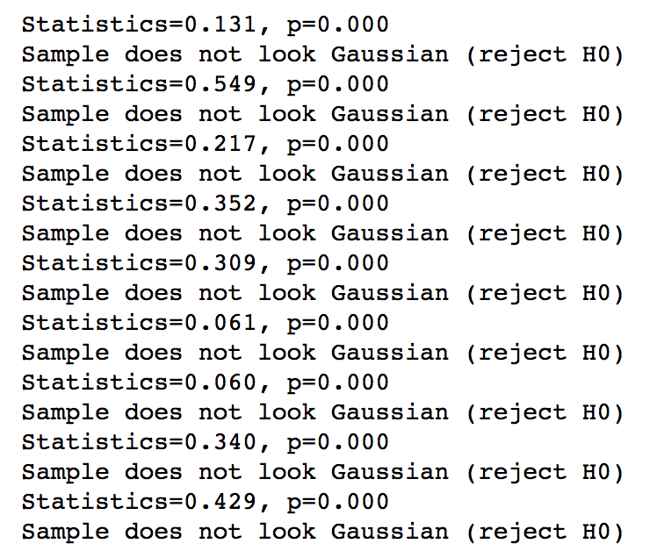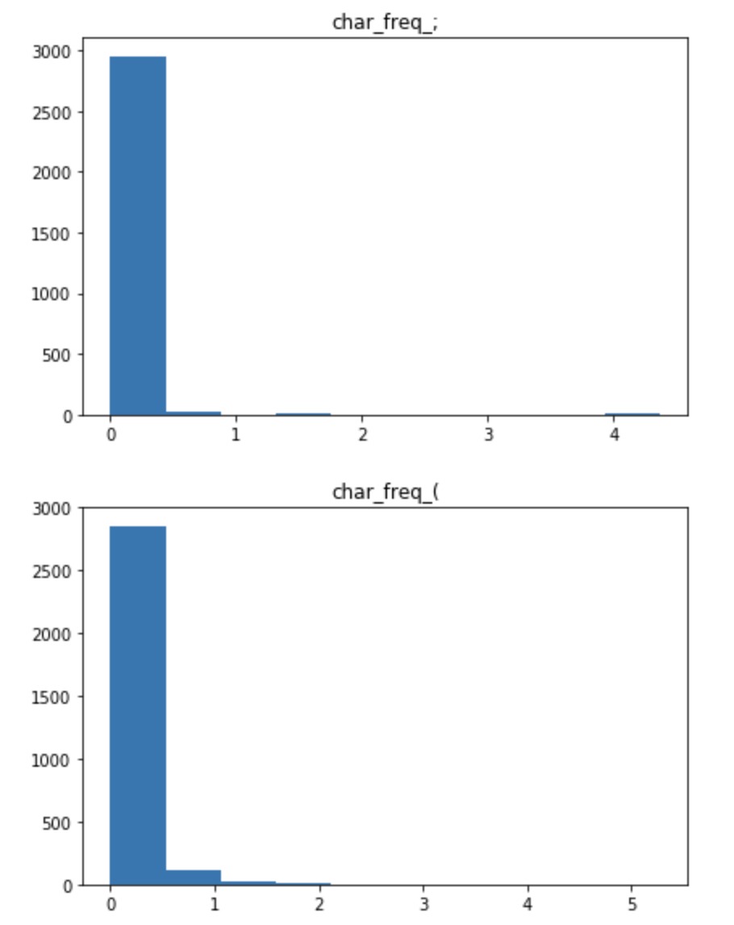

We ran the Shapiro Wilk and Pearson's test against the training data and we got the result as non-gaussian data. Shapiro Wilk and Pearson's test are tests of normality, i.e. it tests the null hypothesis that the data is drawn from the normal distribution or not. We get the if the p-value as less than the chosen alpha level, so the null hypothesis is rejected and there is evidence that the training data are not normally distributed.

A limitation of Naive Bayes is the assumption of independent predictors. In real life, it is almost impossible that we get a set of predictors which are completely independent.